Survival and Migration of Light-Duty Vehicles Across the United States
David L. Greeneª
Benjamin P. Leard^{b}
Arthur Yip^{c}
Ruixiao Sun^{d}

The University of Tennessee
ªDepartment of Civil and Environmental Engineering
dlgreene@utk.edu
and
^{b}Baker School of Public Policy and Public Affairs
1640 Cumberland Avenue
Knoxville, Tennessee 37996-3340
United States of America
bleard@utk.edu

^{c}National Laboratory of the Rockies
Center for Integrated Mobility Sciences
15013 Denver West Parkway
Golden, CO 80401
Arthur.Yip@nlr.gov

^{d}Oak Ridge National Laboratory
Vehicle and Mobility Systems Research
2360 Cherahala Boulevard
Knoxville, Tennessee 37932
sunr@ornl.gov

Corresponding author:
Ruixiao Sun

Analyzing the Survival and Migration of Light-Duty Vehicles Across the United States
David L. Greene, University of Tennessee
Benjamin P. Leard, University of Tennessee
Arthur Yip, National Renewable Energy Laboratory
Ruixiao Sun, Oak Ridge National Laboratory

July 2026
Abstract
The stocks of passenger cars and light trucks in operation evolve differently across the United States due to differences in new vehicle purchases and because used vehicles migrate from one state to another and vehicle survival rates vary. The differences may have important implications for the diffusion of advanced automotive technologies, such as automated and electric vehicles. We use state registration-based vehicle survival rates from 2014-2024 to estimate the magnitude of net imports/exports of newer used vehicles by state and develop models of state-level vehicle net survival using regression analysis and machine learning. Our analysis indicates substantial and persistent flows of 2-to-8-year-old vehicles among states. We observe that the COVID pandemic caused changes in vehicle registration rates and reporting procedures that had drastic effects on the net survival rate data. For predicting future state vehicle survival rates, we find that machine learning (ML) models produce more accurate descriptions of state net survival rates for passenger cars, sport utility vehicles (SUV) and vans, and pickup trucks than dynamic adjustment models estimated by least squares regression with fixed effects.
Acknowledgment
This research was authored in part by authors at the University of Tennessee and the Oak Ridge National Laboratory managed by UT-Battelle, LLC for the U.S. Department of Energy (DOE) under contract No. DE-AC05-00OR22725 and in part by authors at the National Laboratory of the Rockies, operated by Alliance for Energy Innovation, LLC, for the U.S. DOE under Contract No. DE-AC36-08GO28308. Funding was provided by the U.S. Department of Energy, Office of Energy Efficiency and Renewable Energy, Vehicle Technologies Office. The content of this report reflects the views of the authors and does not necessarily represent the views of the University of Tennessee, Oak Ridge National Laboratory, the National Renewable Energy Laboratory, or the U.S. DOE.

- Objectives
Motor vehicles dominate U.S. transportation, accounting for 87% of passenger-miles traveled. Light-duty vehicles represent 87% of all highway vehicles (USDOT/BTS, 2025) and used vehicles constitute approximately 95% of vehicles in operation (USDOT/BTS, 2025). As technologies such as automation and electrification transform transportation, understanding the temporal and spatial dynamics of the evolution of used vehicle stocks and their impacts on energy, the environment, traffic safety and mobility may have important implications for policies to adapt to and manage the transition and deploy supporting infrastructure (Leard and Greene, 2023; Newman et al., 2024; USEPA, 2026; USDOT, 2025)
For example, the market shares of EVs vary by an order of magnitude across U.S. states. As of the third quarter of 2025, the market shares of new all-EV plus plug-in hybrid electric vehicles (PHEV) ranged from 31 percent in California, 29 percent in Colorado, and 20 percent in Washington State to 2 percent in Wyoming, West Virginia and North Dakota and 1.4 percent in Oklahoma (AAI, 2025). Although EVs constituted 12.6 percent of U.S. new light-duty vehicle sales in Q3 2025, EVs made up only 1.4 percent of vehicles in operation (Experian, 2025). Given such large differences in new vehicle market shares, how used vehicles migrate across states could have important implications for the diffusion of EVs, their charging infrastructure needs and impact on the electricity grid (e.g., Palm, 2022).
Scrappage and survival rates of light-duty vehicles have been well studied at the national level (see, e.g., Cramer, 1958; Walker, 1968; Parks, 1977; Greene and Leard, 2024a; Jacobsen and van Benthem, 2015) as have their implications for traffic safety, energy transition and greenhouse gas mitigation (e.g., Leard and Greene, 2023; Woody et al., 2020; USDOT, 2025; USEPA, 2026). The economic and environmental effects of international trade in used vehicles in North America (Olguín et al., 2023; Chen et al., 2018; Davis and Kahn, 2010) and worldwide have also received attention (Shi et al., 2022; Ayetor et al., 2021; Velten et al., 2020; Fuse et al., 2009; Clerides, 2008; Nieuwenhuis et al., 2007) . However, migrations of used vehicles among states and differences in state vehicle survival rates have received little attention from researchers. The Energy Information Administration’s Transportation Sector Demand Model documentation states that vehicle scrappage is modeled at the level of nine U.S. Census Divisions (EIA, 2022a), however the only depictions of the scrappage functions are in a set of presentation slides which note that they are not to be cited (EIA, 2022b). In an unpublished research report, Greene et al. (2025) presented preliminary results of statistical analyses of state net vehicle survival rates for passenger cars, SUVs and pickup trucks. Variable selection analysis by backward and forward stepwise regression and by lasso indicated that net survival rates were primarily influenced by economic and demographic growth rates. Net survival functions fitted to the state data using least squares regression fit many states’ data well, however, for some states the fits were poor and not suitable for predicting future state survival rates.
The first contribution of this paper is deriving quantitative estimates of the interstate migrations of 2- to 8-year-old used vehicles by three vehicle classes based on state vehicle net survival rates. The paper’s second contribution is demonstrating that machine learning (ML) methods can produce accurate representations of state-level net survival rates.
- Methods
In the U.S., annual changes of registrations of a certain vehicle type from one state to another occur because of two types of transitions: (1) movements of the vehicle type from state $s$ to state due to migration by its owner (e.g., Jin et al., 2022; Rashidi et al., 2011) or sale and resale in response to differences in supply and demand for used versus new vehicles (e.g., Zabritski, 2023; Brown, 2024) which we denote as migration, and (2) a fraction of the vehicle type remaining in operation versus being scrapped, which we denote as survival. Scrappage denotes taking a vehicle out of operation by sending it to a junk yard to be disassembled or destroyed. In the U.S. 20% to 30% of new vehicle transactions are leases, creating a substantial supply of vehicles to the used market every year (e.g., Zabritski, 2023). New car sales to rental companies are typically on the order of 1 to 2 million units per year, creating another source of relatively young used vehicles (Brown, 2024).
The ideal data for analyzing interstate movements of used vehicles consist of individual vehicle registrations and their unique vehicle identification numbers (VINs). State Departments of Motor Vehicles collect such raw data but it is processed by private market research firms that consider the resulting databases proprietary and essential to their core business. As a result, we could not obtain detailed data by VIN and state. Instead, our data consists of net survival rates, $r_{jast}$, equal to the number of vehicles of body style $j$ (j = car, SUV + van, and pickup truck) and age $a$ in state $s$ in year $t$, $n_{jast}$, divided by the number of vehicles of the same type and one year younger age $a-1$ in $s$the previous year, $n_{j\left(a-1\right)s(t-1)}$ . Age is estimated by subtracting a vehicle’s model year from the calendar year. The net survival rate statistics were derived from proprietary registration counts but the original counts cannot be derived from the net survival rates without additional proprietary data. Therefore, we observe only the combined effects of vehicle migration and survival which we call net survival. The data used in our empirical analysis includes vehicles owned by government agencies, companies, and households. Previous analysis of vehicle scrappage and survival have shown meaningful differences in survival functions for the three vehicle types (Greene and Leard, 2024a). However, the designs of the vehicles in each class change over time which means the attributes of vehicles of different ages are not identical.
We call the observed state survival rates, $r_{jast}$, “net survival rates” because they include the effects of vehicles that are permanently retired from service (scrapped) between years t-1 and t, denoted as ${retire}_{j\left(a-1\right)s\left(t-1\right)t}$, plus the migration of vehicles into and out of state s between years t-1 and t, which we denote as ${in}_{j(a-1)s(t-1)t}$ and, ${out}_{j\left(a-1\right)s\left(t-1\right)t}$, respectively in equation (1).
$$\begin{aligned}r_{jast}=\frac{n_{j\left(a-1\right)s(t-1)}-{retire}_{j\left(a-1\right)s\left(t-1\right)t}+in_{j\left(a-1\right)s\left(t-1\right)t}-out_{j\left(a-1\right)s\left(t-1\right)t}}{n_{j\left(a-1\right)s(t-1)}} \#\left(1\right)\end{aligned}$$
Figure 1 shows the 2014-to-2024 raw state net survival rates in gray dots and the national survival rates in black dots. Net survival rates decline for the first 20-25 years but then increase. State net survival rates are far more variable than national survival rates because state-to-state differences in survival rates tend to offset each other at the national level. Figure 1 also shows anomalies. The lowest net survival rates for vehicles greater than 30 years old, both national and state are for the year 2020 and reflect the unique effect of the COVID pandemic on vehicle survival rates (e.g., Hulse, 2026) but also registration regulations and accounting practices during the pandemic (AALA, 2020). Most of the extreme COVID data are pickup trucks. Finally, the variance of the state net survival rates increases with vehicle age, particularly after 30 years, while the numbers of vehicles in operation decreases. Graphs of the state data by year show other anomalies and outliers, discussed below.
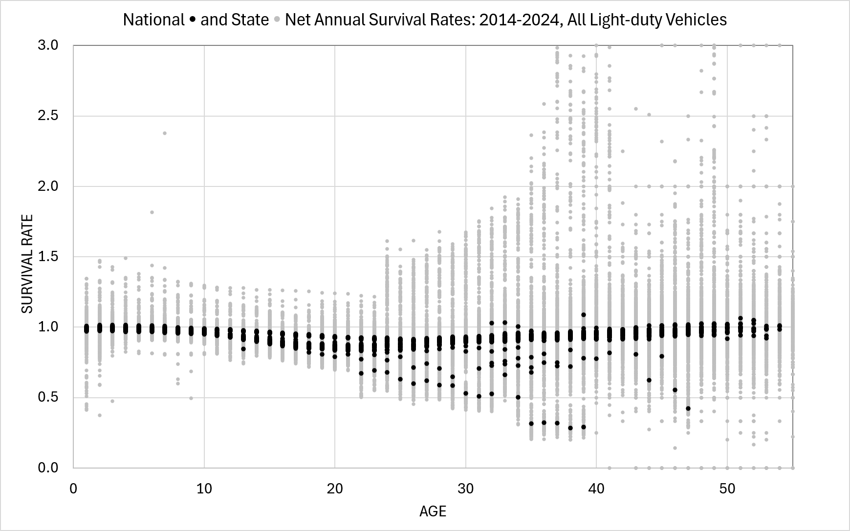
Figure 1. National and State Raw Annual Net Survival Rates for All Light-duty Vehicles: 2014-2024
State net survival rates differ in important, systematic ways from national survival rates. A sample of six states for the year 2019 is shown in Figure 2, with the U.S. national rate represented by the dashed black line. Some states, especially in the South, Midwest and Mountain West (like Alabama, Idaho, and Texas) generally have net survival rates higher than the national average for newer used vehicles. Other states such as Michigan, New York and New Jersey, have markedly lower survival rates for used vehicles. Net survival rates exceeding 1.0 suggest net migration of vehicles into the state while net migration rates less than 1.0 suggest emigration and possibly accelerated scrappage. Survival rates typically decrease until 20-25 years of age and then increase. Beyond about 30 years, relatively few vehicles remain in operation and the net survival rates become noisier. Survival rates for 1-year-old vehicles differ from those of other ages because they generally do not include unsold inventories of the full production of the model year in question.
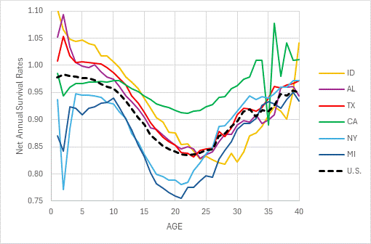
Figure 2. Observed 2018 Passenger Car Net Survival Rates for Six States and the U.S.
We created a measure of state net imports (imports – exports) of younger used vehicles based on the difference between state and national survival rates. True scrappage rates for newer used vehicles are close to 1% because few vehicles are scrapped in their early life due to their high value. We compute the national survival rate as $survival_{jat}=n_{jat}/n_{j\left(a-1\right)(t-1)}$. The estimated fraction of a-year-old vehicles in state s imported or exported in year t is assumed to be the difference between the state survival rate and the national survival rate: $f_{jast}=r_{jast }-survival_{jat}$ Positive values for $f_{jast}$ represent net imports and negative values for $f_{jast}$ represent net exports. The corresponding fraction of y-year old (2≤y≤8) vehicles is estimated by the sum of imports or exports from 2 to y, weighted by their respective cumulative survival rates.
$$\begin{aligned}cumulative_{jst}=\sum_{a=2}^{y}{f_{jast}}\prod_{i=2}^{a}{r_{jast}} \#\left(2\right)\end{aligned}$$
We calculated values for equation (2) for each year 2015-2024 and averaged the annual estimates by state. The results for the three vehicle types (Figures 3a-3c) show the average net number of vehicles of each type leaving the state (lefthand side, purple) and the net additions (righthand side orange). California, New York, Florida, New Jersey, and California are large net exporters of 2-to-8-year-old cars, SUVs and vans, while Texas is the leading net exporter of younger used pickups.
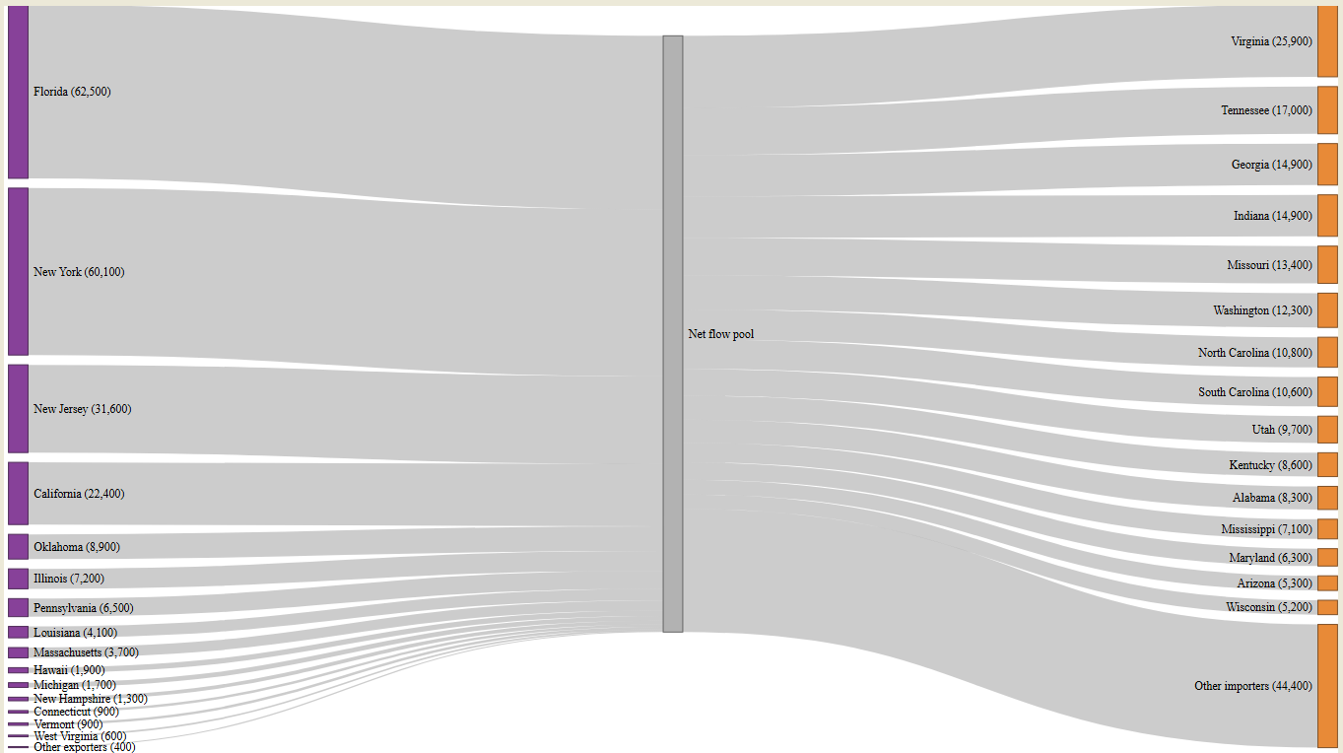
Figure 3a. Estimated net imports and exports of 2-to-8-year-old passenger cars 2014-2024.
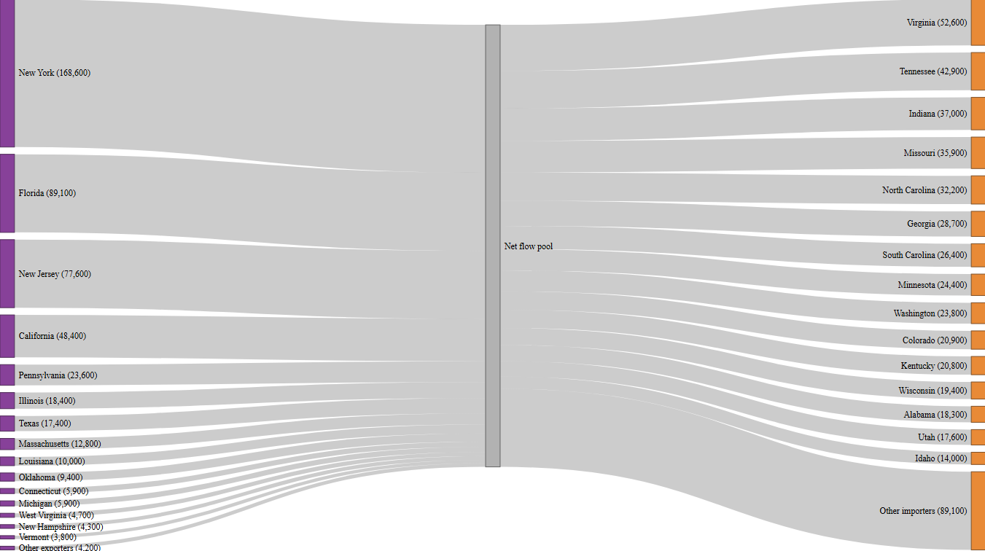
Figure 3b. Estimated net imports and exports of 2-to-8-year-old SUVs and vans 2014-2024.

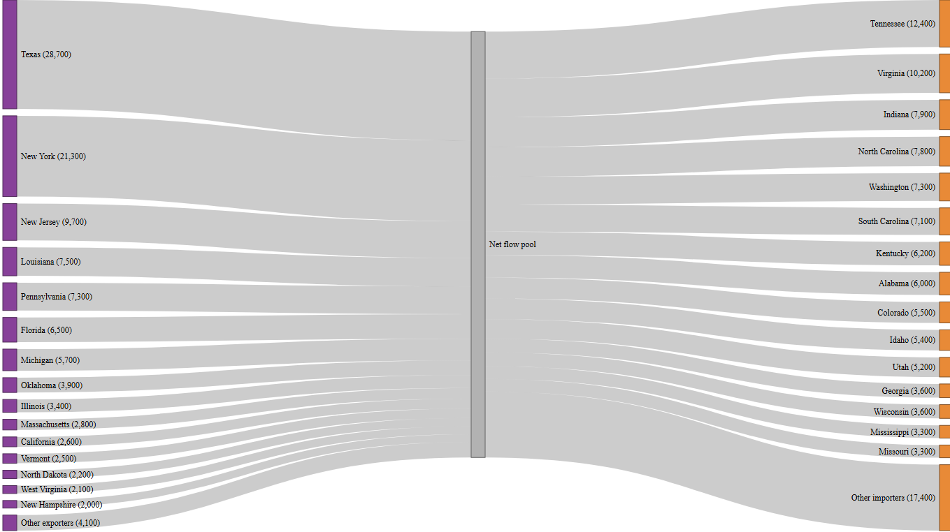
Figure 3c. Estimated net imports and exports of 2-to-8-year-old pickups 2014-2024.

Continue with descriptions of the OLS fixed-effect regression method followed by the ML method and reasons for using both.
Past modeling of the evolution of the stock of vehicles in operation has represented vehicle survival by fixed rates of survival (or scrappage) or mathematical functions of vehicle age (Greene and Leard, 2024). The U.S. Department of Transportation’s CAFE model (USDOT, 2025b) is an exception, an econometrically estimated model that includes the growth rate of GDP, new vehicle prices and fuel costs as exogenous variables. We found that logistic functions that fit national scrappage and survival rates by vehicle type well (Greene and Leard, 2024) could not fit the variety of state survival rates well, even when fitting individual state functions. Below we describe the results of estimating state survival rates using Least Squares with fixed effects and machine learning.
Our data were conditional survival rates (the probability of surviving to age a+1 given survival to age a) by three vehicle classes (passenger cars, SUVs and vans, pickup trucks) for all 50 states, for the calendar years 2014 to 2024. After examining graphs of the survival rates by state, year and vehicle type, we eliminated vehicles less than two years old due to the effects of unsold inventories on apparent survival rates, and we dropped vehicles older than 35 years due to the small numbers of vehicles and extreme variance in state survival rates. The graphs and survival rate data were also found to contain anomalies and extraordinary effects caused by the COVID19 pandemic in 2020, with an apparent rebound effect for older used vehicles in 2022. Anomalies included a few implausible, uniformly high survival rates for all vehicles in Tennessee in 2014 and in Virgina, Maryland and Missouri in 2022. We created fixed effect variables to account for these anomalies and the effects of the pandemic in 2020 and 2022.
We estimated the equation (3) for net vehicle survival rates, $r_{vsat}=\frac{n_{jsat}}{n_{jsa-1t-1}}$ , using the regress procedure of Stata™ and the robust option to correct for heteroscedasticity. In the equation (3) the subscript j is omitted because separate models are estimated by vehicle type.
$$r_{sat}=α_{0}+λr_{sat-1}+\sum_{t=2014}^{2024}{γ_{t}d_{3t}+}\sum_{a=a_{j}}^{35}{δ_{a2020}d_{a2020}}+θ\left(\frac{x_{st}}{x_{st-1}}\right)+ω\left(\frac{z_{st}}{Z_{st}}\right)+α_{TN}d_{TN2015}+ε_{sat}$$
The α’s, β’s, δ’s, γ’s, and θ, ω, and λ are coefficients to be estimated, while the d’s are fixed effect (0,1) variables and ε is an error term. Equation 3 includes fixed effects for calendar years, for state-year anomalies, and for older vehicles in years affected by the COVID pandemic. The year fixed effects represent factors that varied by year at the national level, such as the effects of nationwide new and used vehicle price increases during the COVID19 pandemic. The x variables are rates of change from one year to the next, such as the growth rate of GDP or population and represent state differences from national temporal factors. The z variables are state variables for time period t relative to a base, or reference, variable, such as net migration per capita or fatalities per 100 million vehicle miles and similarly represent difference from national averages. Ratios are used instead of totals, like state total population or total GDP because the net survival dependent variable is a ratio. Specific vehicle type equations differ due to adding more fixed effects to account for anomalies or by including different rate or state variables.
The lagged dependent variable is included to better represent the differing forms of state-specific survival functions. State and age effects are omitted to reduce collinearity and the “Nickell bias” that occurs when the lagged dependent variable is included in estimations using time-series, cross-sectional data with fixed effects (Nickell, 1981). The magnitude of the bias is generally on the order of 1/T percent, where T is the number of time periods, here 10. Potential x and z variables were selected from a list developed by Greene et al. (2025) based on their statistical significance and variable inflation factor (vif) values. The inclusion of the lagged dependent variable requires that when fixed effect variables are entered to represent anomalies, such as caused by the COVID pandemic for example, a second set of fixed effects must be included the following year to account for the presence of the same effect in the lagged dependent variable.
Machine Learning methods here.

- Findings
Results of the regression analysis support the belief that movements of newer used vehicles among states are driven primarily by demographic and economic factors. Coefficients of the growth rates of the driving age population and personal income are positive (increase survival rates) and significant at the 0.001 level in the models of all three vehicle types. The driving age population growth rate performed better than net migration most likely because it includes both migration and indigenous population growth. In all three vehicle type equations, survival rates were negatively affected by growth in vehicle miles traveled (VMT). In the pickup model, a greater share of the population with bachelor’s degrees or higher reduced pickup survival rates, which may indicate an out-migration of used pickups to states with lower levels of advanced degrees. Greater VMT per vehicle was associated with increased car and pickup survival rates which may indicate longer lifetimes in rural states with higher vehicle usage.
Given the unique effects of the COVID19 pandemic on 2020-2022 registrations and registration record keeping, and the number of apparent anomalies in the data, we consider the regression model result to be a combination of statistical inference and curve fitting. The one-period lagged dependent variable, for example, was included as much to improve the fit to state specific survival rates as to represent the possibility of dynamic adjustment of survival rates to changes in economic and demographic factors. Their coefficients range from 0.69 (Pickup) to 0.76 (SUV & van) to 0.87 (Car), implying that the long-run impacts of economic and demographic variables are several times their short-run (1 year) impacts.
Variable Inflation Factors indicate that despite the many fixed effects multicollinearity is moderate. FEs representing the pandemic and other anomalies were generally slightly larger than 1.0, while the year FEs ranged from 1.0 to 4.4 for the COVID year of 2020. VIFs for economic and demographic variables ranged from 1.0 to 3.4 (VMT growth), while VIFs for the LDV ranged from 1.7 and 1.8 for Cars, SUVs and vans to 4.4 for pickups.
Although the OLS models with lag-1 survival rates fit the state level data with adjusted R² values between 0.75 and 0.88 and RMSEs between 0.031 and 0.041 (Table 1), residual plots, particularly for older pickups in several states exhibited patterns indicating lack of fit. For this reason, we attempted to fit state level survival models using machine learning.
Variable
 | Passenger Cars | SUVs & Vans | Pickups
Lagged survival rate | +0.8721*** | +0.7639*** | +0.6946***
Pop>16 growth rate | +0.0066*** | +0.0059*** | +0.0108***
Personal income growth rate | +0.0532*** | +0.0504*** | +0.2180***
GDP growth rate |  | +0.0417*
VMT growth rate | -0.0600*** | -0.1096*** | -0.1146***
Fatalities/vehicle |  | +0.0026*
VMT/vehicle | +4.39e-07*** |  | +6.50-e-07***
R² | 0.823 | 0.753 | 0.880
RMSE | 0.0304 | 0.0406 | 0.0356
P-values: *** <0.001, **<0.01, *<0.05
- Novelty
To our knowledge this is the first attempt to estimate net migrations of used vehicles by state and indicates substantial net movements of 2-8-year-old used cars, SUVs and vans and pickups. This study also appears to be the first effort to estimate state-specific survival rates by vehicle type and indicates that survival rates at the state level are sensitive to economic and demographic growth rates.
- Practical Applications
The functions estimated by machine learning and least squares regression with fixed effects may be useful for projecting future vehicle survival rates and net migration among states. State vehicle survival models could be important for forecasting and analyzing the impacts of the diffusion of advanced vehicle technologies such as connected and automated vehicles and electric vehicles. These technologies have important implications for vehicle safety and environmental quality and require substantial investments in supporting infrastructure from communications and charging stations to workforce development.
We believe/do not believe that we have adequately demonstrated how reliable forecasting models can be developed from state vehicle survival rate data. The severe disruption of historical patterns of survival rates, apparently due to the combined effects of the pandemic on vehicles in operation and the reporting of vehicle registrations by state DMVs, complicated the task of estimating survival functions. Further research and testing seems necessary to establish the reliability of the models we have developed and their usefulness in modeling the evolution of vehicle stocks and vehicle migrations at the state level.
References

- References
- Alberini, A., M. Bareit, M. Filippini, A.L. Martinez-Cruz, 2018. “The impact of emissions-based taxes on the retirement of used and inefficient vehicles: The case of Switzerland,” Journal of Environmental Economics and Management, 88: 234-258.
- Alliance for Automotive Innovation (AAI), 2026. “Get Connected: Electric Vehicle Quarterly Report,” Third Quarter 2025. https://www.autosinnovate.org/posts/papers-reports/get-connected-ev-quarterly-2025-q3.
- American Automotive Leasing Association (AALA), 2020. “Motor Vehicle Titling/Registration and Transaction Issues Due to Impact of COVID-19 Pandemic”, 5/11/2020. https://static1.squarespace.com/static/57fd39c9197aea31fab2c5ed/t/5eb95424784e22464676e3a4/1589204005356/AALA+COVID-19+Status+Update+05.11.2020.PDF .
- M. Sackey, P. Andoh, 2021. “Vehicle regulations in Africa: Impact on used vehicle import and new vehicle sales”. Transportation Research Interdisciplinary Perspectives, 10. https://doi.org/10.1016/j.trip.2021.100384.
- Bento, A., K. Roth and Y. Zuo, 2018. “Vehicle Lifetime and Scrappage Behavior: Trends in the U.S. Car Market,” The Energy Journal, 39(1): 159-183. https://www.researchgate.net/publication/322177636_Vehicle_Lifetime_Trends_and_Scrappage_Behavior_in_the_US_Used_Car_Market .
- Bomey, N., 2020. “Long wait at the DMV: Car owners face delays registering vehicles or signing titles as offices close or scale back due to COVID-19”. USA Today, 5/15/2020. https://www.usatoday.com/story/money/cars/2020/05/15/dmv-electronic-title-registration-cars-trucks-coronavirus-covid-19/5182830002/ .
- Brown, C., 2024. “Rental Fleet Sales Still Well Below Pre-COVID Norms”, Auto Rental News, Bobbit Business Media, Inc., accessed on 3/13/2026 at https://www.autorentalnews.com/10226731/rental-fleet-sales-still-well-below-pre-covid-norms#:~:text=Rental%20Fleet%20Sales%20Drop%20the,lower%20than%20those%20for%202019.
- Brownstone, D. D. Bunch, T. Golob and W. Ren, 1996. “A transactions choice model for forecasting demand for alternative-fuel vehicles”, Research in Transportation Economics. 4: 87-129. https://www.sciencedirect.com/science/article/pii/S0739885996800072.
- Burra, L., M. Kasawaneh and C. Cirillo, 2024. “Impact of charging infrastructure on electric vehicle adoption: A synthetic population approach,” Travel Behaviour and Society, 37 (2024). https://doi.org/10.1016/j.tbs.2024.100834.
- Campbell, C., M. Dwyer and J. Maples, 2022. “Annual Energy Outlook 2023 Planned modeling and data updates in the transportation sector”, presentation slides of the AEO2023 Transportation Working Group, September 15, 2022. U.S. Energy Information Administration. https://www.eia.gov/outlooks/aeo/workinggroup/transportation/pdf/AEO2023-Presentation.pdf .
- Chen, L., B. Garcia-Medina, and R. Wan, 2019. “Trade liberalization, consumption shifting and pollution: Evidence from Mexico's used vehicle imports”. Review of International Economics, 27:1591-1608. https://doi.org/10.1111/roie.12436.
- Clerides, S., 2008. “Gains from trade in used goods: Evidence from automobiles”. Journal of International Economics, 76(2):322-336. https://doi.org/10.1016/j.jinteco.2008.07.009 .
- Consumer Affairs, 2025. https://www.consumeraffairs.com/automotive/used-car-statistics.html.
- Cox Automotive, 2021. “Commentary: Independent Dealers are Poised to Thrive as Driving Force in Recovery,” https://www.coxautoinc.com/market-insights/commentary-independent-dealers-are-poised-to-thrive-as-driving-force-in-recovery/.
- Cramer, J., 1958. “The Depreciation and Mortality of Motor-Cars,” Royal Statistical Society. Journal. Series A: General, 121(1): 18–46. https://doi.org/10.2307/2342989.
- Davis, L. and M. Kahn, 2010. “International Trade in Used Vehicles: The Environmental Consequences of NAFTA”, American Economic Journal: Economic Policy, 2(4):58-82.
- Dou X. and J. Linn, 2020. “How do US passenger vehicle fuel economy standards affect new vehicle purchases?”. Journal of Environmental Economics and Management, 102: 102332. https://www.sciencedirect.com/science/article/pii/S0095069620300553 .
- Experian, 2025. “Electric Vehicles: 2024 Year in Review”. https://www.experian.com/content/dam/marketing/na/automotive/infrographic/EV-Infographic/electric-vehicles-2024-year-in-review.pdf .
- Federal Highway Administration (FHWA), 2023. Traffic Volume Trends December 2023. https://www.fhwa.dot.gov/policyinformation/travel_monitoring/23dectvt/23dectvt.pdf.
- Fuse, M., H. Kosaka and S. Kashima, 2009. “Estimation of world trade for used automobiles”. Journal of Material Cycles and Waste Management, 11:348-357. https://doi.org/10.1007/s10163-009-0263-3.
- FRED, 2025. “Light Weight Vehicle Sales: Autos and Light Trucks” Federal Reserve Bank of St. Louis. https://fred.stlouisfed.org/series/ALTSALES .
- Greene, D.L., B.P. Leard, A. Yip, R. Sun and R.K. Bose, 2025. “State Differences in Light-Duty Vehicle Survival Rates”, Center for Energy, Transportation, and Environmental Policy, The University of Tennessee, Knoxville. https://baker.utk.edu/wp-content/uploads/2025/04/State-Level-UVM-report-compressed.pdf , https://trid.trb.org/View/2563702 .
- Greene, D.L. and B.P. Leard, 2024a. “Trends in scrappage and survival of U.S. light-duty vehicles,” Transportation Research A: Policy and Practice, 180: https://doi.org/10.1016/j.tra.2024.103982.
- Greene, D.L. and B.P. Leard, 2024b. “MA3T Used Vehicle Model Documentation,” unpublished manuscript of March 27, 2024, available from the authors. Baker School of Public Policy and Public Affairs, University of Tennessee, Knoxville, TN.
- Greene, D.L. and B.P. Leard, 2024c. “Enhancements to the ORNL MA3T Used Vehicle Model to Enable Analysis of Taxes, Subsidies and Other Policies Directed at Used Vehicles,” Unpublished project report, available from the authors, Baker School of Public Policy and Public Affairs, University of Tennessee, Knoxville, TN.
- Greene, D., E. Kontou, B. Borlaug, A. Brooker, M. Muratori, 2020. “Public charging infrastructure for electric vehicles: What is it worth?,” Transportation Research D, vol. 78: 102182, https://doi.org/10.1016/j.trd.2019.11.011.
- Greenspan, A. and D. Cohen, 1999. “Motor Vehicle Stocks, Scrappage and Sales,” Review of Economics and Statistics, 81(3): 369-383.
https://www.jstor.org/stable/2646761?seq=1
- Hawley, R.E., 2024. “Car depreciation: What it is and how it works,” Bankrate. https://www.bankrate.com/insurance/car/understanding-car-depreciation/.
- Jacobsen, M., R. Beach, C. Cowell, and J. Fletcher, 2021. “The Effects of New-Vehicle Price Changes on New- and Used-Vehicle Markets and Scrappage,” EPA-420-R-21-019, U.S. Environmental Protection Agency, Office of Transportation and Air Quality, https://cfpub.epa.gov/si/si_public_record_Report.cfm?dirEntryId=352754&Lab=OTAQ .
- Jacobsen, M.R. and A.A. van Benthem, 2015. “Vehicle Scrappage and Gasoline Policy,” American Economic Review, 105(3): 1312-1338.
- Jin, L., A. Lazar, C. Brown, B. Sun, B. Garikapati, S. Ravulaparthi, Q. Chen, A. Sim, K. Wu, T. Ho, T. Wenzel, C. Spurlock, 2022. “What Makes You Hold on to That Old Car? Joint Insights From Machine Learning and Multinomial Logit on Vehicle-Level Transaction Decisions”. Frontiers in Future Transportation. 3: 894654, doi: 10.3389/ffutr.2022.894654 .
- Junk Car Reaper, 2024. “Average Vehicle Lifespan in the USA: A State-by-State Analysis”, internet article accessed at https://www.junkcarreaper.com/guides/vehicle-lifespans/ on 6/11/2025.
- Leard, B. and D. Greene, 2023. “Coordinating the Electric Vehicle Transition and Electricity Grid Decarbonization in the U.S. is Not Essential to Achieving Substantial Long-Term Carbon Dioxide Emissions Reductions,” Environmental Research Letters, 18(7), 074035. https://iopscience.iop.org/article/10.1088/1748-9326/acdd85.
- Lin, Z., D. Greene and J. Ward, 2025. User Guide of the ORNL MA3T Model (V20130729). Available at teem.ornl.gov/ma3t.shtml.
- Losacker, S., H. Hansmeier, J. Horbach and I. Leifner, 2023. “The geography of environmental innovation: a critical review and agenda for future research”. Review of Regional Research, 43:291–316. https://doi.org/10.1007/s10037-023-00193-6 .
- Newman, S., K. Schulte, M. Morellini, C. Rahal and D. Leasure, 2024. “Offshoring emissions through used vehicle exports”. nature climate change, 14:238-241. https://doi.org/10.1038/s41558-024-01943-1 .
- Nickell, S., 1981. “Biases in Dynamic Models with Fixed Effects”, Econometrica, 49(6): 1417-1426.
- Nieuwenhusi, P., A. Beresford and P. Choi, 2007. “Shipping Air? Tracking and Forecasting the Global Shipments of New and Used Cars”. IV(3): 17-36. ISSN: 1697-4840.
- Olguín, F., G. Iskakov and A. Kendall, 2023. “US-Mexico second-hand electric vehicle trade: Battery circularity and end-of-life policy implications”, Transportation Research D: Transport and Environment, 125. https://doi.org/10.1016 /j.trd.2023.103934.
- Palm, A., 2022. “Innovation systems for technology diffusion: An analytical framework and two case studies”. Technological Forecasting and Social Change, 182: 121821. https://doi.org/10.1016/j.techfore.2022.121821 .
- Parks, R., 1977. “Determinants of Scrapping Rates for Postwar Vintage Automobiles,” Econometrica, 45(5), 1099-1115. https://www.jstor.org/stable/1914061.
- Rashidi, T., A. Mohammadian, and F. S. Koppelman, 2011. "Modeling interdependencies between vehicle transaction, residential relocation and job change," Transportation, 38(6): 909-932. doi: 10.1007/s11116011-9359-4.
- Shi, Y., T. Arthanari, V. Venkatesh, S. Islam and V. Mani, 2022. “Used vehicle global supply chains: perspectives on a direct-import model”. Supply Chain Management: An International Journal. 27(3): 333–347. https://doi.org/10.1108/SCM-06-2020-0238.
- Stata Corp., 2025. Stata 19 Lasso Reference Manual, College Station Texas, Stata Press.
- Tibshirani, R., 1996. “Regression Shrinkage and Selection Via the Lasso”, Journal of the Royal Statistical Society: Series B (Methodological), 58(1):267–288, https://doi.org/10.1111/j.2517-6161.1996.tb02080.x
- U.S. Census Bureau, 2024a. State-to-State Migration Flows. “Table 1. State-to-State Migration Flows¹: 2023 American Community Survey 1-Year Estimates” by year, 11/2024. https://www.census.gov/data/tables/time-series/demo/geographic-mobility/state-to-state-migration.html.
- U.S. Census Bureau, 2024b. “State Population Totals and Components of Change: 2020-2023,” and “Annual Estimates of the Resident Population for the United States, Regions, States, the District of Columbia, and Puerto Rico: April 1, 2010, to July 1, 2019; April 1, 2020; and July 1, 2020.” https://www.census.gov/data/tables/time-series/demo/popest/2020s-state-total.html.
- U.S. Census Bureau, 2024c. “Historical Population Change Data (1910-2020).” https://www.census.gov/data/tables/time-series/dec/popchange-data-text.html.
- U.S. Census Bureau, 2024d. State Area Measurements and Internal Point Coordinates 2010, accessed at https://www.census.gov/geographies/reference-files/2010/geo/state-area.html .
- U.S. Bureau of Economic Analysis (BEA), 2024. Regional Data: GDP and Personal Income, “SASUMMARY State annual summary statistics: personal income, GDP, consumer spending, price indexes, and employment,” https://apps.bea.gov/itable/?ReqID=70&step=1#eyJhcHBpZCI6NzAsInN0ZXBzIjpbMSwyOSwyNSwzMV0sImRhdGEiOltbIlRhYmxlSWQiLCI2MDAiXSxbIk1ham9yX0FyZWEiLCIwIl1dfQ==.
- U.S. Department of Commerce (USDOC), Bureau of the Census, Foreign Trade Division, 2025a. TPIS Database USHS EXPORTS, Revised Statistics for 1989-2023, Unrevised Statistics for 2024. https://trade.gov/data-visualization/used-vehicle-trade-data-visualization.
- U.S. Department of Commerce (USDOC), International Trade Administration, 2025b. “Used Vehicle Trade Data Visualization”, U.S. Exports of Used Passenger Vehicles TOTAL Exports HTS Units and U.S. Imports of Used Passenger Vehicles TOTAL Imports HTS Units. https://www.trade.gov/data-visualization/used-vehicle-trade-data-visualization .
- 5. U.S. Department of Transportation (USDOT), National Highway Traffic Safety Administration, Notice of Proposed Rulemaking (NPRM), 2025a. “The Safer Affordable Fuel-Efficient (SAFE) Vehicles Rule III for Model Years 2022 to 2031 Passenger Cars and Light Trucks”. Accessed at https://www.govinfo.gov/content/pkg/FR-2025-12-05/pdf/2025-22014.pdf .
- U.S. Department of Transportation, National Highway Traffic Safety Administration, 2025b. Draft Technical Support Document: The Safer Affordable Fuel-Efficient (SAFE) Vehicles Rule III for Model Years 2022 to 2031 Passenger Cars and Light Trucks. December. https://www.nhtsa.gov/sites/nhtsa.gov/files/2025-12/CAFE-SAFE-MY-2022-2031-NPRM-TSD-tag-v2.pdf .
- U.S. Department of Transportation (USDOT), Bureau of Transportation Statistics, National Transportation Statistics 2025. https://www.bts.gov/topics/national-transportation-statistics, tables 1-11, 1-40 and 1-50.
- U.S. Energy Information Administration, 2022. Transportation Sector Demand Module of the National Energy Modeling System: Model Documentation. Page 80. https://www.eia.gov/outlooks/aeo/nems/documentation/transportation/pdf/transportation-2022.pdf .
- U.S. Environmental Protection Agency (USEPA), 2026. “Rescission of the Greenhouse Gas Endangerment Finding and Motor Vehicle Greenhouse Gas Emission Standards Under the Clean Air Act”, Federal Register, Vol. 91, No. 32. Accessed at https://www.govinfo.gov/content/pkg/FR-2026-02-18/pdf/2026-03157.pdf .
- Velten, E., C. Brauer, and J.-E. Thie, 2020. “Used vehicle trade and fleet composition in Europe”. Final report of the project “Used vehicle trade and fleet composition in Europe” on behalf of the EEA. Ecologic Institute and Fraunhofer Institute for Systems and Innovation Research ISI: Berlin, Karlsruhe.
- Walker, F., 1968. “Determinants of Auto Scrappage,” Review of Economics and Statistics, 50(4): 503- 506.
- Zabritski, M., 2023. “State of the Automotive Finance Market Q1 2023”, earlier and later reports, Experian Information Solutions, Inc., accessed on 3/13/2026 at https://www.experian.com/content/dam/noindex/na/us/automotive/finance-trends/2023/2023-q1-state-auto-finance-market.pdf .

This manuscript was supported and authored in part by authors at Oak Ridge National Laboratory, operated by UT-Battelle, LLC, under contract DE-AC05-00OR22725 with the US Department of Energy (DOE) and in part by authors at the National Laboratory of the Rockies, operated by Alliance for Energy Innovation, LLC, for the U.S. DOE under Contract No. DE-AC36-08GO28308. The publisher acknowledges the US government license to provide public access under the DOE Public Access Plan (https://www.energy.gov/doe-public-access-plan). The content of this report reflects the views of the authors and does not necessarily represent the views of the University of Tennessee, Oak Ridge National Laboratory, the National Renewable Energy Laboratory, or the U.S. Department of Energy.
Net exports of used passenger cars and light trucks from the U.S. to other countries are not considered in this analysis because they are not identified in our data and because they are a small fraction (0.3%) of U.S. car and light truck registrations (U.S. Dept. of Commerce, 2025a; FHWA, 2023). Unfortunately, the USDOC data are totals and do not disaggregate used vehicle imports and exports by used vehicle age. Exports of used passenger vehicles from the U.S. typically exceed used vehicle imports by more than an order of magnitude (USDOC, 2025b). Using data on total U.S. scrappage from Greene and Leard (2024a) and USDOC (2025b) we estimate that U.S. net exports of used passenger vehicles averaged 6.8% of total light-duty vehicle scrappage from 2003 to 2020, with a standard deviation of 1.2%.
Market research on the average lifetime of vehicles by state can be found on the internet (e.g., Junk Car Reaper, 2024).
This happens for various reasons, such as a significant mechanical failure or irreparable damage in a traffic accident. It is also possible for vehicles to disappear from our data if owners decide not to register a vehicle yet retain ownership. We expect this to be a very minor occurrence, except perhaps in the year of the COVID pandemic, a possibility we discuss below.
The state-level annual net survival rates from January 1 to January 1 of the following year were provided by the National Laboratory of the Rockies (NLR) for the years 2014 to 2024, by three vehicle types: passenger car, SUV and van, and pickup truck.
It is possible that the vehicle types could be further disaggregated by fuel type, e.g., gasoline, hybrid, and electric. However, scrappage rates for hybrid and especially electric vehicles do not exist for older age vehicles, which would limit our analysis to relatively young vehicles for those fuel types. Therefore, in this study, we restrict our definition of vehicle type to body style.
Net survival rates increasing with age around 20-25 years old could be due to several factors. At some point in a vehicle’s life, it becomes a collector’s item, giving owners an incentive to maintain the vehicle and avoid scrapping the vehicle. Another reason may be due to the heterogeneity in people’s willingness to extend the life of a vehicle. Some people may be willing to take time and effort to keep a vehicle running not because it is part of a collection, but because of a desire to maintain a machine for as long as possible.
The data were derived from proprietary vehicle counts purchased from Experian™ by the National Laboratory of the Rockies and provided to us with the expressed permission of Experian™.

